MACHINE VISION

MINI PROJECT

RICE QUALITY TESTING

MEX5271

GROUP MEMBERS

P. A. HEWAPATHIRANA 613344004

W. I. A. PERERA 613345350

N. DADALLAGE 713344839

SUBMITTED DATE : 18/10/2017

CENTER : COLOMBO

**TABLE OF CONTENT**

List of Illustrations ii

1. Introduction x
2. Aim x
3. Objectives x
4. Goals x
5. Technologies used x
6. Methodology x
   1. Vision based system development x
   2. Algorithm development for decision making x
7. GUI (Graphical User Interface) x
8. Conclusion x
9. References x

**LIST OF ILLUSTRATIONS**

*Figure 6.1 – Original Image (Left) and the Gray scaled image (Right) 3*

1. **INTRODUCTION**

Rice is the single most important food in the Asian countries, especially in Sri Lanka. Averagely rice cultivation occupies 37% from the total cultivation in Sri Lanka. For the global demand, from our country, rice is exported to the other countries (approximately 1000 MT) and global rice demand is increase by 1.95% annually. More people consume rice as food, so demand is getting increased day by day. Due to this the quality of the exported and even the locally circulating rice should have a good standard. Else the local demand will be reduced and more will go after importing rice which will not so great for the economy of the country with the current economic situation. So doing a thorough quality testing has become a must.

For the purpose of testing the quality of the rice grain the image processing techniques can be used. The quality of the rice grain is based on the several parameters. Such as,

* Grain color
* Shape
* Size.

Machine vision systems are used to identify the quality of the grain. Digital images and videos are the key sources of the machine vision systems.

The task to advance through this mini project is to develop a vision based system which capable to predict broken rice percentage in a given rice sample. In addition to that the application develop to a mobile application which fulfils the modern requirements in mobile platforms and to be flexible to test out the quality of the rice anywhere you are, other than using a bulky setup to identify the quality of the rice sample at the palm of your hand.

1. **AIM**

To develop a vision based system and mobile application to identify broken percentage of a given rice sample.

1. **OBJECTIVES**

* To develop a vision based system.
* To develop a mobile application for the task.

1. **Goals**

* To develop a mobile application.
* To develop an algorithm which occupies the decision making from final output.

1. **Technologies used**

* Development Environments,
  + Visual studio **[5.1]**- for debugging and developing.
  + Android studio **[5.2]** - for the mobile development.
* Libraries used,
  + OpenCV **[5.3]**
* Testing Environments
  + MS Core.NET environment – for debugging and testing.
  + Genymotion Emulator **[5.4]**– for mobile testing.
  + Android 6.0 (API 23) mobile device – for testing.

1. **Methodology**

* **Assumptions made out.**
* There should be a considerable difference between the grain colors and the background.
* There should be at least one proper grain.
* There should be a proper light condition during the task.
* Grains must not be overlapped with one another.

**The system development process**

Original image

Gray scaling

Gaussian smoothing

Erosion

Thresholding

Canny detection

Area calculation

Classification of grains

* 1. **Vision based system development.**
* **Gray scaling**

Grayscale is range of monochromatic shades from black to white. Therefore, a grayscale image contains only shades of gray and no color. The process of gray scaling removes all color information, leaving only the luminance of each pixel.

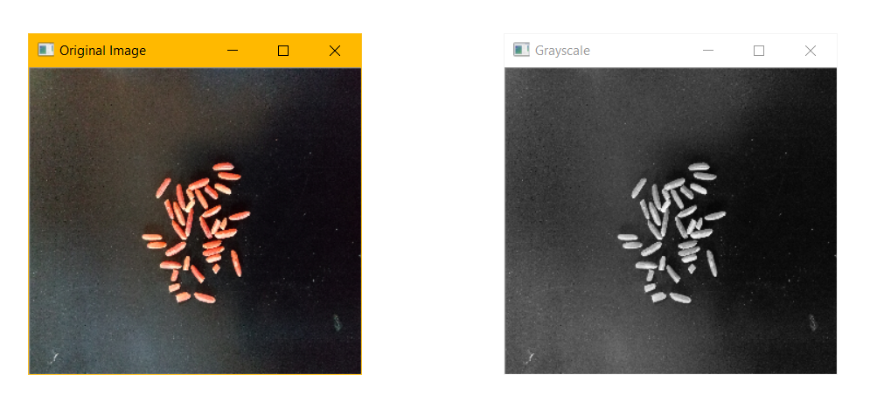

*Figure 6.1 – Original Image (Left) and the Gray scaled image (Right)*

**Code Snippet**

*//Create a Mat image from image path*Mat src = *imread*(**picPath**, CvType.***CV_8UC4***);  
Mat srcEdited = **new** Mat();  
  
*//Convert Original src to grayscale*Imgproc.*cvtColor*(  
 src, *// input image* src, *// output image* Imgproc.***COLOR_BGR2GRAY***); *//conversion method*

* **Gaussian smoothing**

Gaussian filtering is used to blur images and remove noise and detail. When working with images we need to use the two dimensional Gaussian function. This is simply the product of two 1D Gaussian functions and is given by,

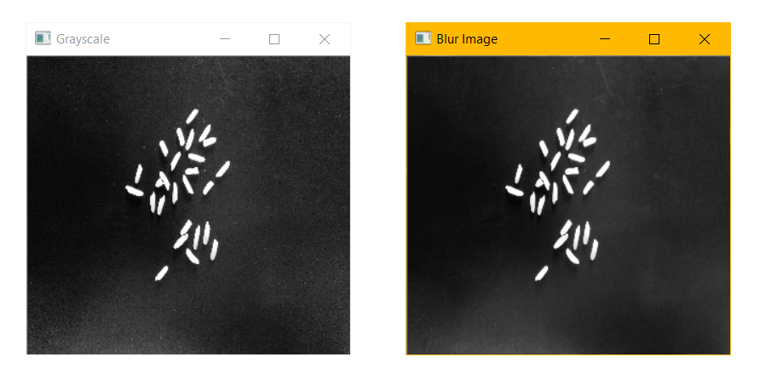

*Figure 6.2 – Gray scaled Image (Left) and the blurred image (Right)*

**Code Snippet**

*//openCV Size variable*org.opencv.core.Size s = **new** Size(9,9);  
*//Apply Gaussian Blur*Imgproc.*GaussianBlur*(  
 src, *// input image* srcEdited, *// output image* s, *// Mask size* 1.5); *// Sigma value of Gauss mask*

* **Erosion**

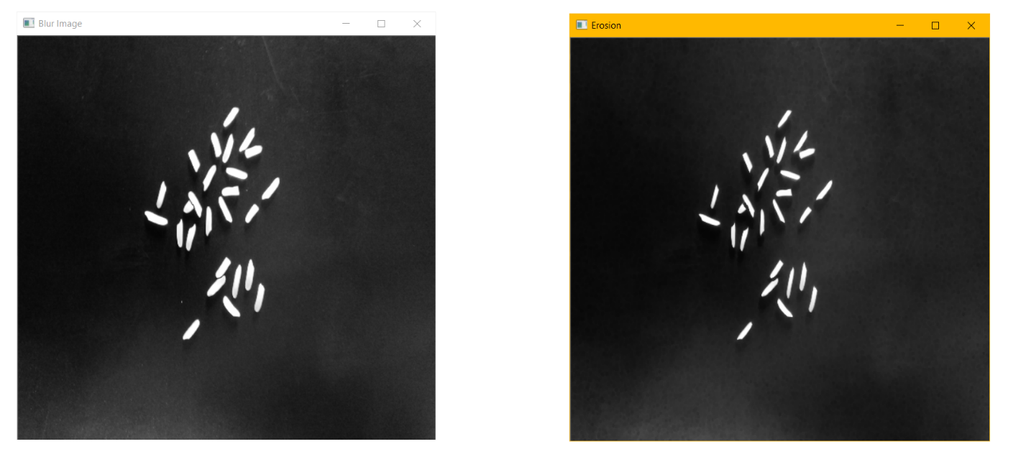The most basic morphological operation in image processing is erosion which removes pixels on object boundaries.

*Figure 6.3 – blurred Image (Left) and the eroded image (Right)*

**Code Snippet**

*//openCV Size variable*org.opencv.core.Size s = **new** Size(21,21);  
Mat kernal = Imgproc.*getStructuringElement*(  
 Imgproc.***MORPH_ELLIPSE***, *// shape* s, *// k size* org.opencv.Point(1,1)); *// anchor position within the*

*element  
//Erode*Imgproc.*erode*(  
 srcEdited, *// input image* srcEdited, *// output image* kernal); *// kernal for erosion*

* **Canny detection**

The canny detector was developed by John F. Canny in 1986. Also known as the optimum detector, canny algorithm aims to satisfy three main criteria,

1. Low error rate : Means a good detection of only existing edges.
2. Good localization : The distance between edge pixels detected and real edge pixels

have to be minimized.

1. Minimal response : Only one detector response per edge.

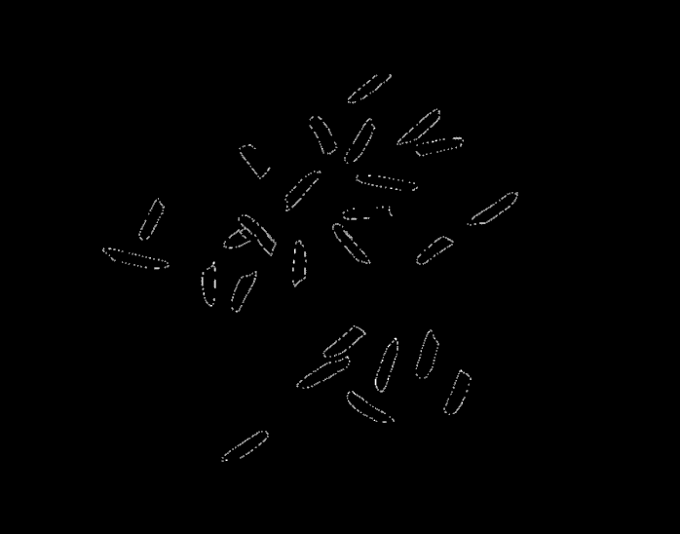

*Figure 6.4 – detected contours in the image*

**Code Snippet**

Imgproc.*Canny*(  
 srcEdited, *// input image* srcEdited, *// output image* 50, *// threshold* 255); *// max threshold*List<MatOfPoint> contours = **new** ArrayList<>();  
Mat hierarchy = **new** Mat(); *// hierarchy mat*Imgproc.*findContours*(  
 srcEdited, *// input image* contours, *// output vector* hierarchy, *// output array of Mat* Imgproc.***RETR_TREE***, *// contour retrieval mode* Imgproc.***CHAIN_APPROX_SIMPLE***);

* **Area Calculation**

**Code Snippet**

**int** counter = 0;  
**double**[] area = **new double**[200];

**for** (**int** contourIdx = 0; contourIdx < contours.size(); contourIdx++) {

*//get the area*

area[counter++] = Imgproc.*contourArea*(contours.get(contourIdx));

Imgproc.*drawContours*(src, contours, contourIdx, **new** Scalar(255, 0, 0), 5);

// debug logger

Log.*d*(***TAG***, **"area: "** + Double.*toString*(area));

}

* 1. **Algorithm development for decision making**

1. **GUI (Graphical user interface)**

GUI – Main Activity

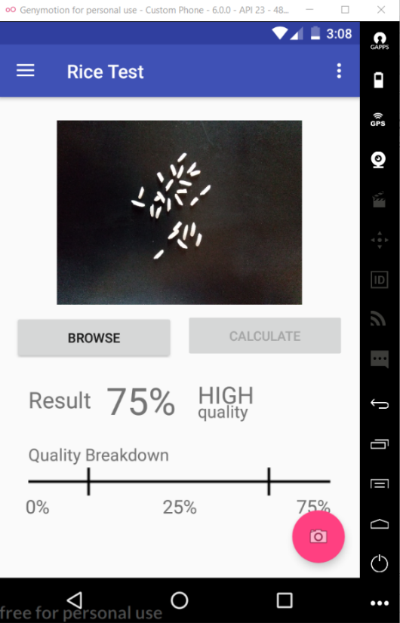

*Figure 7.1 – UI of the Main Activity*

GUI – Settings Activity

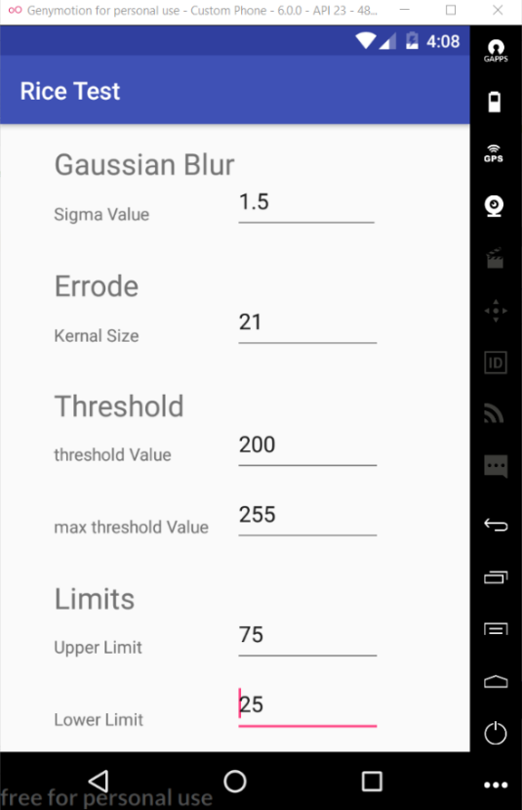

*Figure 7.2 – UI of the Settings Activity*

1. **conclusion**

* Dsadsa

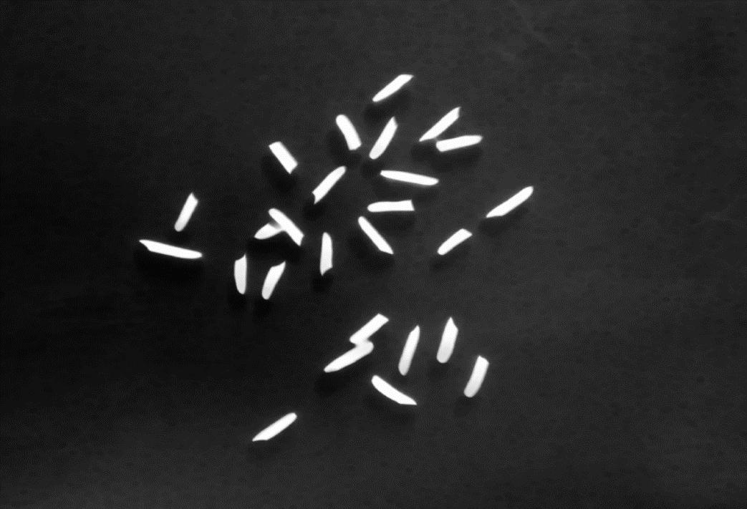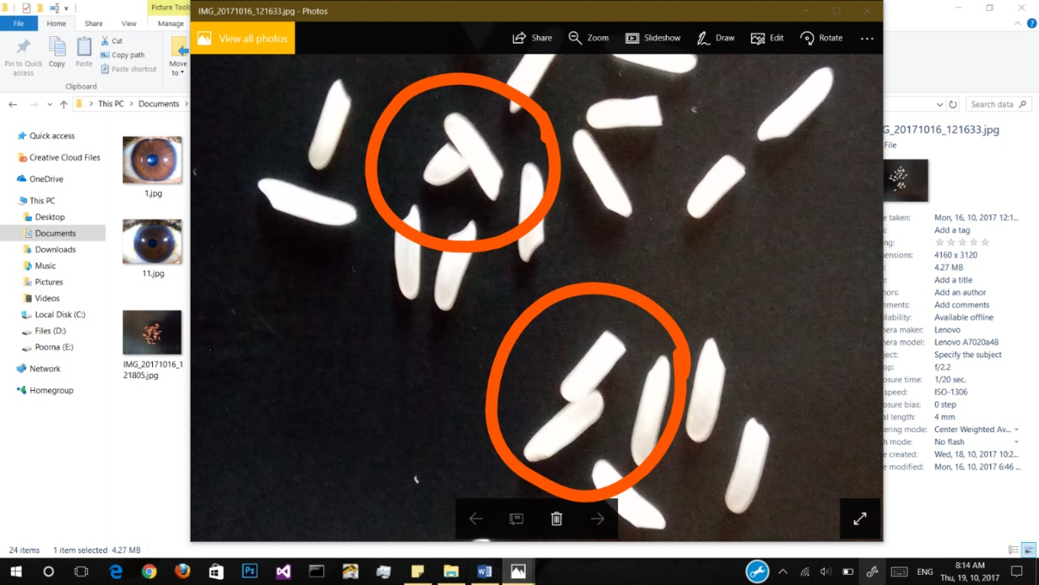

*Figure 8.1 – Before (Left) and after (Right) applying Erosion*

1. **references**